**APC WEEK COMMITTEE - Minutes of the Meeting**

Date: December 14, 2017

Attendance:

|  |  |
| --- | --- |
| Name | Unit/Organization/Department |
| Vincent C. Barcelona | SAO |
| *---------* | Admissions |
| Katherine Gale Hernandez | SHS |
| Krisper Jane H. Bariuan | SOAR |
| Manuel F. Magbuhat | SoM |
| Johanna Minglana | ERC-SoMA/ SS-ER |
| Mary Anne Romero | Marketing |
| Deeno Lapira | ERC-SoMA/ SS-Publishing |

**MOTM Post Evaluation APC WEEK 2017**

* Clarifications in the document:
  + There is a representative for SoMA – Sir Deeno
  + In the document, change “Trophie Room” to “Trophy Room”.

**APC WEEK**

* **Instead of the word seminar, choose another. (Workshop etc.)**
  + Student may ask or think – (What’s in it for me?)
* **Faculty and staff – Sport fest**
* Collaboration of faculty and staff
* Sports included:
  + Badminton
  + Volleyball
  + Basketball
  + Table tennis

|  |  |  |  |  |
| --- | --- | --- | --- | --- |
| Sport | Badminton | Volleyball | Basketball | Table Tennis |
| Coordinator | Miss Johanna Minglana | Osler Aquino, Arnel Aragon | *Sir* | *Sir Kim* |

* Forms for people who want to signed up
* Set up the time per sport.
* Wednesday – Best suggested day for this event. (March 14, 2017)
* Photo shoot per team
* Faculty and staff (friendship games)
* Top 4 teams (students) will also have a photo shoot.
* Vince Barcelona will talk to HR (for prizes)
* Contact companies/ sponsors
* Cheering competition for students
* **Mini Mercato**
  + Maximum of 8 booths
  + Healthy and more choices
  + Contact RJ Ledesma (Mercato owner)
* **RAMS Night**
* Teaser of performances for RAMS Night– (Not dragging) At cafeteria
* Sponsors
  + Taters (willing to sponsor) - meet with them
  + San Miguel corporation – Manny Magbua (point person)
* Alumni is invited
  + APCRAA
  + Batch Host
* **OFFICIAL APC WEEK 2018 – T SHIRT DESIGN CONTEST**
* Same shirt with different colour(per school/shs) – with purchasing fee
* February – Month of processing
* Prize: 5 Movie tickets
* Use RAM as the theme (with or without the use of #)
  + **#WeAreRams**
  + **#RAMPRIDE**
  + **#PROUDTOBERAM**
* Criteria/Mechanics/Judges
  + Get mechanics from the PAG concert
  + Judging: End of January
* January 3, 2017 - Launch the contest
* February 3, 2017 – Winner announcement
* **Opening of APC WEEK 2018 – Morning (March 12, 2017)**
* Classes are priority
* Talk to teachers – first period (7:30 AM- 9:30 AM)
* Talk to Miss Tata about the students being excused – at first period
* **Mobile Application is developed for seminars.**
  + Implementation
* **Activity Proposals**
* January 6, 2017 – Submit early Activity Proposals
* Poster – on activity proposals – Katherine Camacho (SOAR – Creatives Officer)
* **Awarding of student organization on APC week**
* Best organizer – on time event etc.
* **List of activities**
  + January 20 - submission of proposed activities
  + Use Microsoft Forms
* **Proposed Schedule of Activities: MARCH 12-16**

|  |  |  |  |  |
| --- | --- | --- | --- | --- |
| Monday | Tuesday | Wednesday | Thursday | Friday |
| Fun run  • Student and faculty  -• 6:30 AM | **Who wants to be a millionaire?**  • AM  • ERC | **Faculty Staff Friendship**  • Gym  • Whole day | **Sports fest Battle for the 1st Place**  • Gym  • Whole day | **Mass** |
| Opening Ceremony  • 8: 00 AM  • APC DC  • APC Pageant Candidates | **RAMS Got Talent**  **•** Lunch time  **•** MPH1 | **Talk at Audi**  • Audi  • Contact Miss | **Sports fest awarding**  **• Gym** | **RAMS NIGHT** |
| Sports fest Battle for 3rd Place  • Gym  • Whole day | **APC IDOL**  **•** PM  • Auditorium  • Find organization who will handle this event• |  | **Pageant (Summer Theme)**  **•** Auditorium  • 6PM – 8PM |  |
|  | **APC OPEN HOUSE**  • Whole Day |  |  |  |

* Early Bird Award at the Opening Ceremony (Prize: Movie Tickets)
* MS Room – Reserve the room for Tuesday. (Contact Reinan Meer – President of MSC)
* Invite NU athletes: Jaja Santiago and Ildefonso
* APC RAMS NIGHT
* Photo booth area to be set up for anybody who wants to join the photo-liking contest
* RAMs Mascot Head project, or c/o RAM Standee cintra board
* **Pageant**
* Opening: Casual (APC SHIRT)
* Wednesday Talent portion
* Friday: Theme wear, casual, and formal wear
* Photo shoot –Half Day – HMUA is also included (contact sir deeno)
* APC Page – post the photos
* Performers - APC NIGHT (BAND, STRINGS, CHORALE, DC)
* Theme: LUAU

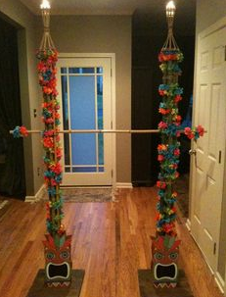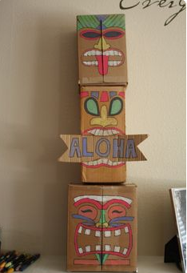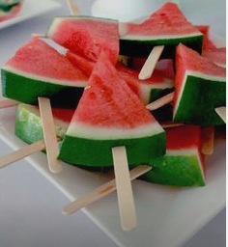

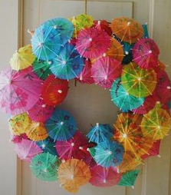

> APC NIGHT

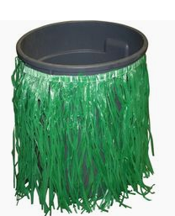



* Suggested clothing for the theme wear of the candidates:



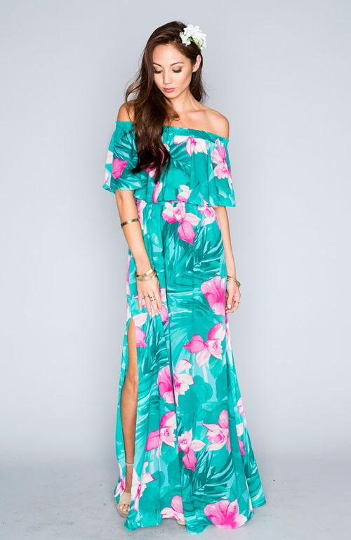



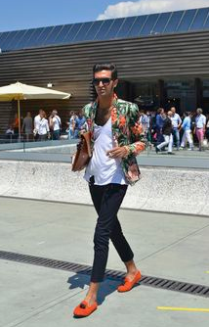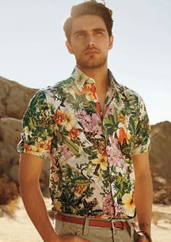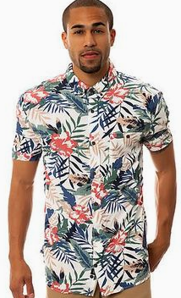

* Delegation of tasks:
  + SMS & PWERSA (tables & stage)
  + REGISTRATION: -- SHS ADHOC – grade 11
  + FOOD: SOAR
  + HOST: SPEAKS
  + TECHNICAL COMMITTEE: MSC, GG, CIPHER
* PHOTOBOOTH
* (Flickers, BB, AnimSoc)
* USHERS & MANPOWER
* JPCS & ROTARACT & PWERSA
* Organizers ID (GENERALIZED)
* Official Organizer ID (laminated)
* SAO Logo & APC
* **Next meeting of the committee:**
* January 10, 2018